**Midterm Exam April 2023**

Question 1. Provide a C++ program to find the third largest string in a given array of strings /2 pts

|  |  |
| --- | --- |
| Input | Output |
| 6  programming  home  exam  grades  schools  job | grades |

Question 2. Provide a program to find the second lowest and third highest numbers in a given array /2pts

|  |  |
| --- | --- |
| Input | Output |
| 5  1 2 3 4 5 | 2 3 |

Question 3. Provide program to count the number of occurrences of a given number in an array of integers. The code should start by asking the number of occurrences you want to check /2pts

|  |  |
| --- | --- |
| Input | Output |
| 12  9 5 3 9 7 5 3 1 2 9 14 11  3 | 9 |

Question 4. Provide C++ program to create and display an original three-digit numbers using 1, 2, 3, 4. Also count how many three-digit numbers are there /3pts

Print every number in 1 line

|  |  |
| --- | --- |
| Input | Output |
|  | 123 124 132 134 142 143 213 214 231 234 241 243 312 314 321 324 341 342 412 413 421 423 431 432 |

Question 5. Split linked list L into L1 and L2. New linked lists will con­tain the alter­nate nodes ***(Node at even position)*** from the given linked list /1.5 pt

|  |  |
| --- | --- |
| Input | Output |
| 5  1 2 1 2 1 | 1 1 1  2 2 |

|  |  |
| --- | --- |
| Input | Output |
| 6  1 2 3 4 5 6 | 5 3 1  6 4 2 |

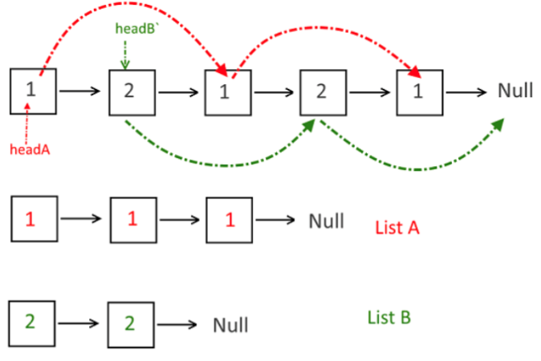

Question 6. Merge linked list L2 into L1 at alternate positions. Make sure the code follow the same pattern for any other couple of lists / 1.5 pt

|  |  |
| --- | --- |
| Input | Output |
| 5  1 2 3 4 5  2  6 7 | 1 6 2 7 3 4 5 |

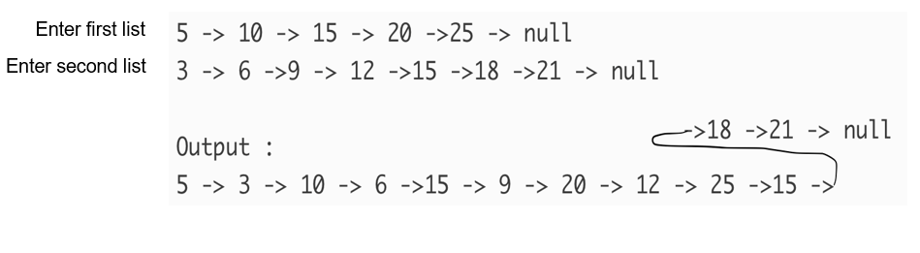

Question 7.

A. simply Explain the difference between the 5 basic sorting algorithms (Selection, Insertion, bubble , merge and quicksort) (Using a diagram or drawing would be much better to understand) / 1 pts.

B. Manually sort the below algorithms using all five-sorting algorithms. The different steps of sorting should be shown /5 pts.

[ 1, 12, 3, 5,7]

8. Provide the time complexity of all the above algorithms (From Question 1 to 7). You can add the time complexity on OJ as comments however you MUST write on the exam paper the final answer. /2 pts

For example

Time complexity

A.Code in Question 1 =O(1)

**NB Use Object Oriented Programming (classes) and using C++**